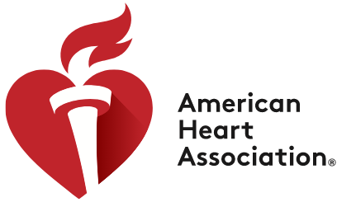

**To** Trina Tardone

**From** Marisa Fischetti, William Chen, Ben Wichman, Taylor Rashti

**Date** September 16, 2020

**Subject** Informative report about the American Heart Association

The [American Heart Association](https://www.heart.org/en) was founded in 1924 by six cardiologists in Chicago. Today, the American Heart Association is one of the top leaders in researching heart disease and [reducing deaths from cardiovascular diseases and stroke](https://www.heart.org/en/about-us/history-of-the-american-heart-association).

**Background**

Before the American Heart Association existed, it was believed that individuals with heart disease were considered bedridden or destined for premature death. The AHA held its first yearly scientific meeting in 1925 to discuss the latest developments about cardiovascular health. Since then, the yearly meetings have become the [biggest annual cardiovascular conference in the USA](https://www.heart.org/en/about-us/history-of-the-american-heart-association). Decades later, the AHA transformed from a scientific community to a voluntary health organization. This transformation allowed for a multitude of ways to raise funds (such as donations, fundraisers, walk to support, and pharmaceutical and biotech companies) to support the AHA’s research and development. Since then, the [American Heart Association’s mission](https://www.heart.org/en/about-us) is “To be a relentless force for a world of longer, healthier lives” and “to see a world free of cardiovascular diseases and stroke.”

**General Information**

The [American Heart Association](https://newsarchive.heart.org/aha-marks-90-years-of-saving-improving-lives/) incorporates many volunteer opportunities such as walking to support health research, becoming a power ambassador at church, host a fundraising event, participate in studies, teach, etc. The website provides the latest news and where the nearest association is to you. The American Heart Association has branches all over the country that help educate its members and provide cardiac aid to try and reduce deaths caused by cardiovascular disease and stroke. Their website offers easy access for anyone looking for information on cardiovascular disease, its symptoms, and different ways that anyone can contribute through volunteer work.

**Results**

As a result of the [American Heart Association](https://newsarchive.heart.org/aha-marks-90-years-of-saving-improving-lives/), the heart disease death rate has dropped about 50 percent over the last 50 years for which official statistics are available. This is due to the advocacy and the efforts that the AHA played over some of the many public policies. For

example, laws were passed that banned smoking from public places, provided healthier food at school, and removed trans fats found in food.